

MATH EXPRESSIONS

Assignment # 6

JAVASCRIPT

1. Write a program to take a number in a variable, do the required arithmetic to display the following result in your browser:

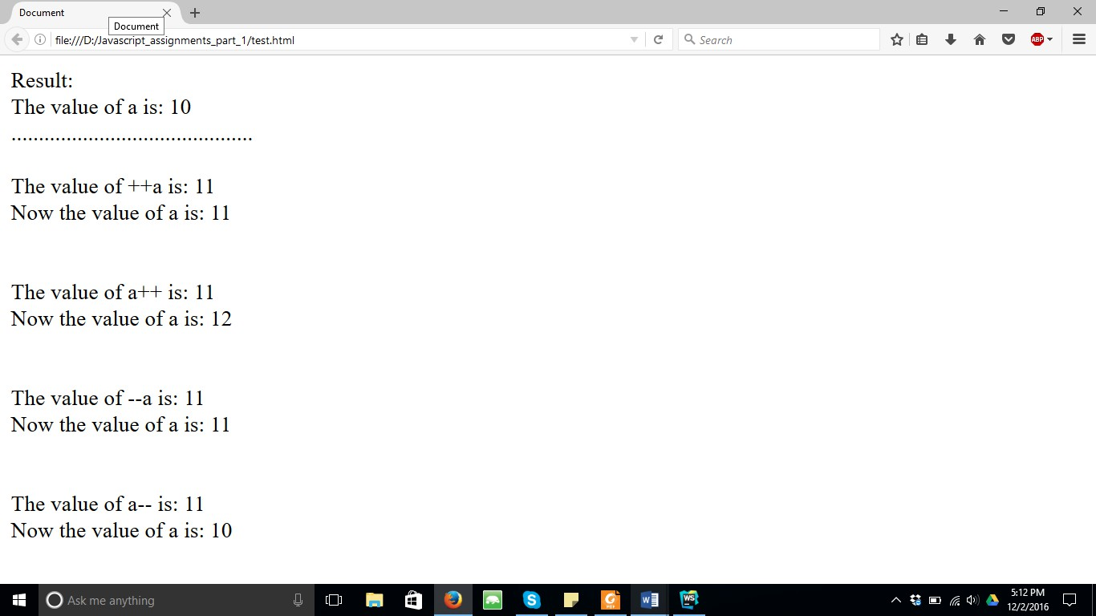

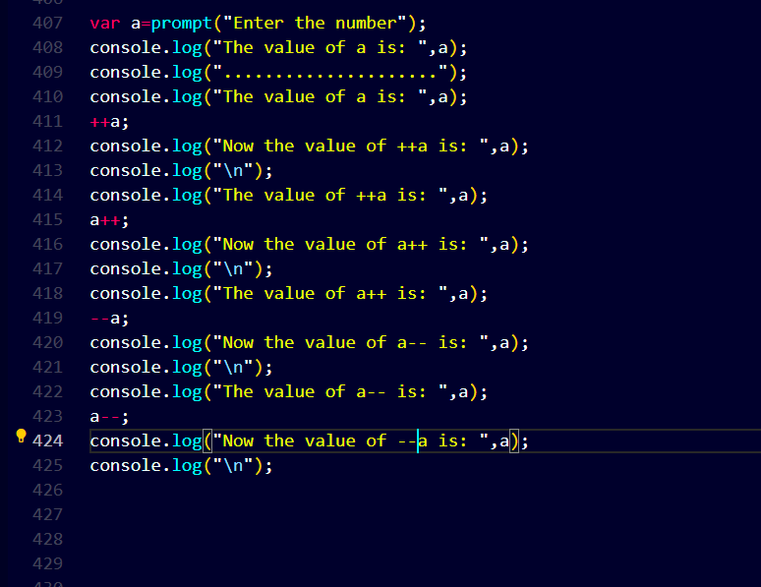

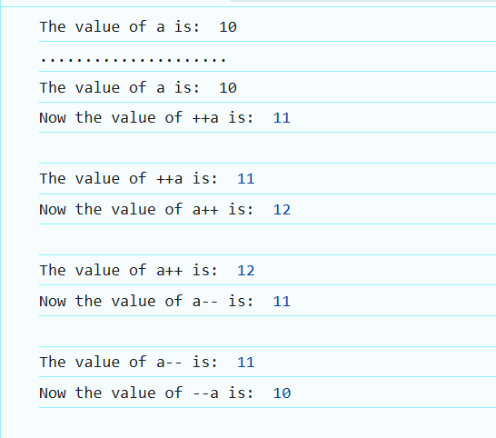

1. What will be the output in variables ***a***, ***b*** & ***result*** after execution of the following script:

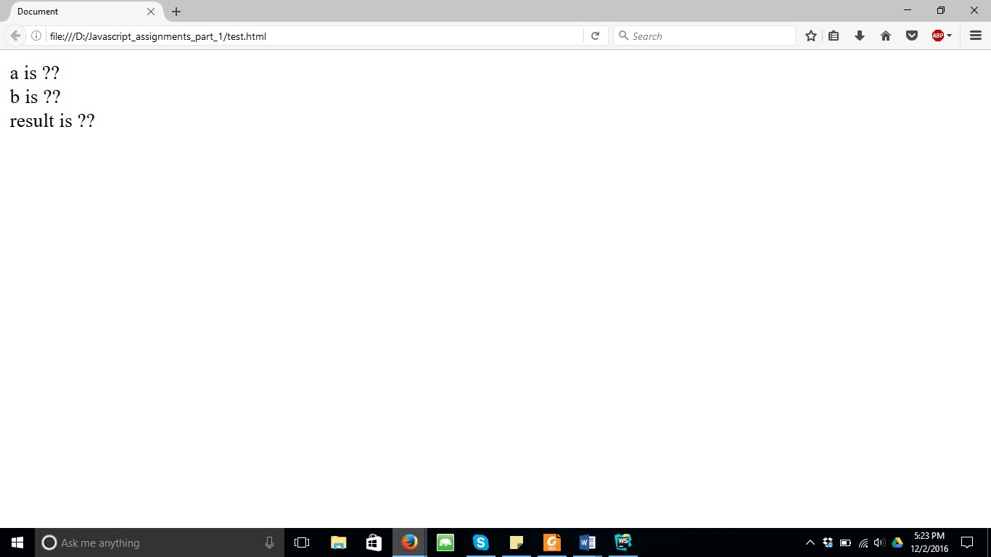

*var a = 2, b = 1;*

*var result = --a - --b + ++b + b--;*

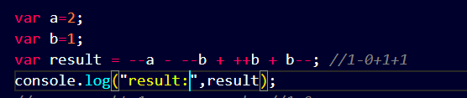

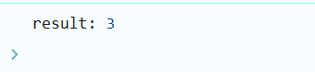

Explain the output at each stage:

*1.--a;*

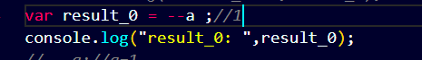

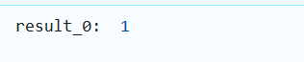

*2.--a - --b;*



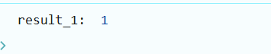

*3.--a - --b + ++b;*



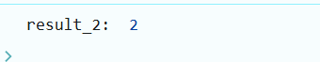

*4.--a - --b + ++b + b--;*

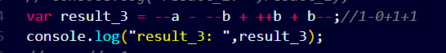

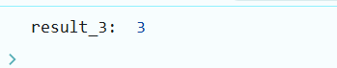

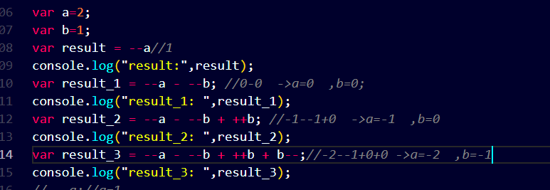

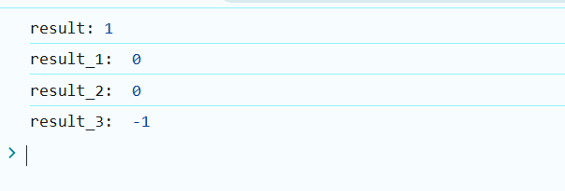

1. Write a program to take input a number from user & display it’s multiplication table on your browser. If user does not enter a new number, multiplication table of 5 should be displayed by default.

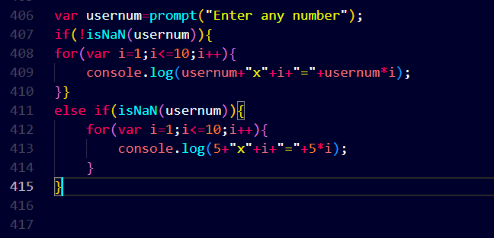

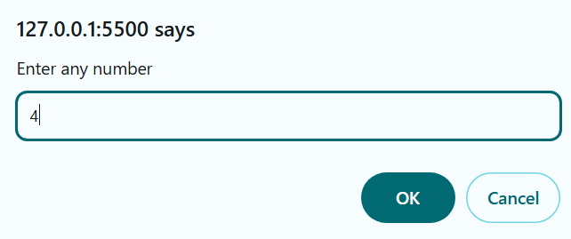

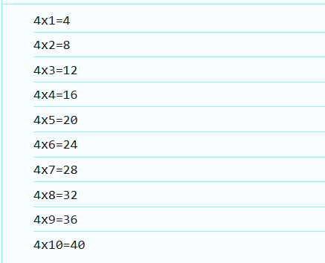

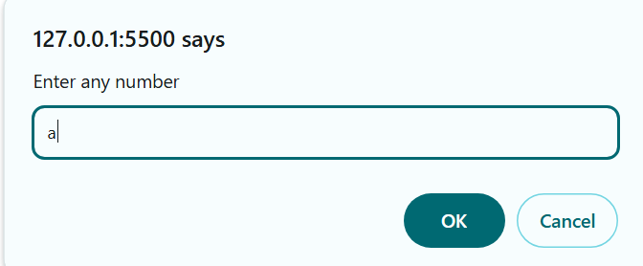

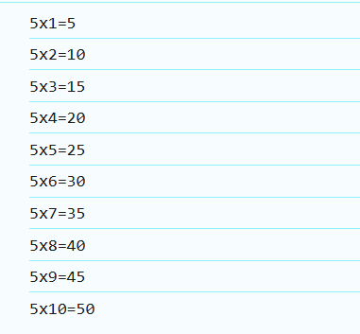

1. Take
   1. Take three subjects name from user and store them in 3 different variables.
   2. Total marks for each subject is 100, store it in another variable.
   3. Take obtained marks for first subject from user and stored it in different variable.
   4. Take obtained marks for remaining 2 subjects from user and store them in variables.
   5. Now calculate total marks and percentage and show the result in browser like this.(Hint: user table)

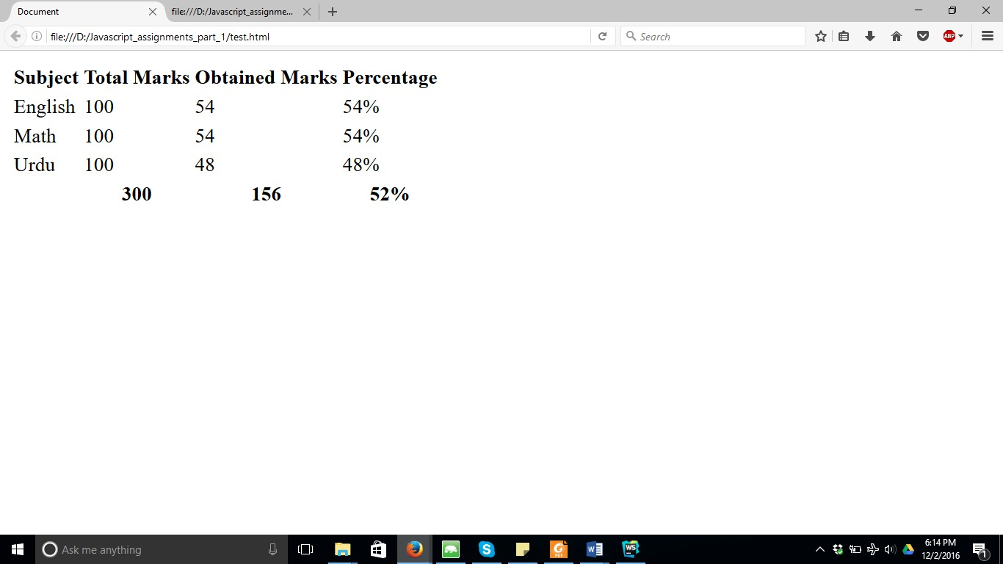

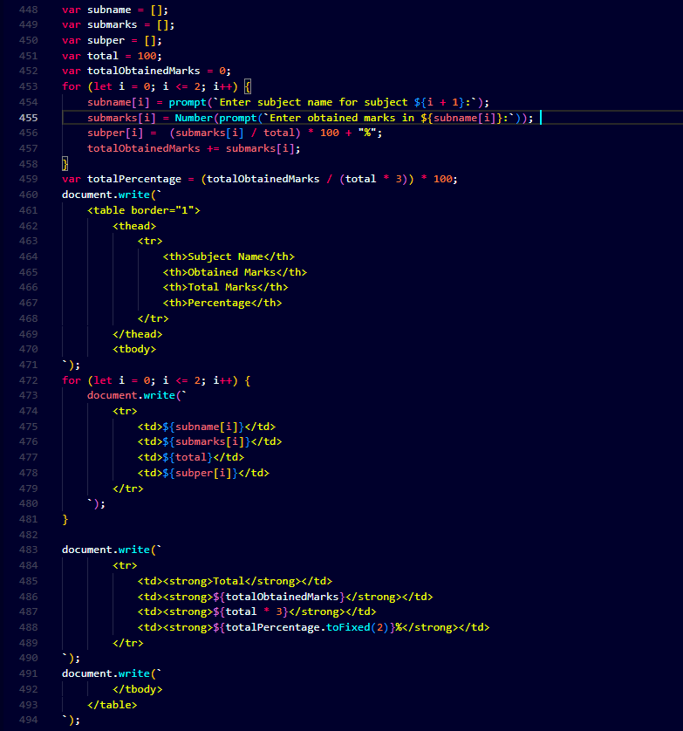

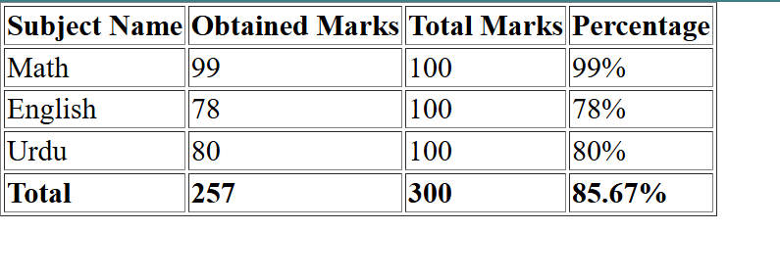

1. Write a program that takes input a name from user & greet the user.

